CS 11A: Technology & Computing Components I
HOS02A – Setting Up Jupyter Notebooks

Reviewed by Vishal Krishna Kumar on 03/26/2026
Reviewed by Sumit K C on 06/11/2026
Reviewed by Clark Ngo on 08/13/2026

School of Technology and Computing (STC) @City University of Seattle (CityU)

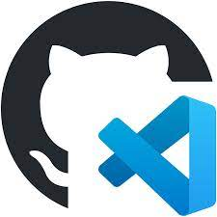

Before You Start
- Screenshots may be different from your environment.
- The directory path shown in screenshots may be different from yours.
- Version numbers may not match the most current version at the time of writing. If given the option to choose between the stable release (long-term support) or the most recent, please select the stable release rather than the beta-testing version.
- The steps might have subtle discrepancies. Please use your best judgment while following this cookbook-style tutorial to complete each step.
- All the steps and concepts in this tutorial are from references, so if you encounter problems, please try to read and compare the references to solve the problem. If you still can't solve the problem, please get in touch with your course Student Assistant.
- Avoid copying code from the book or the GitHub repository. Instead, type out the code yourself. Resort copying only when you are stuck and find things that are not working as expected.
- Some steps may not be explained in detail. If you are not sure what to do:
  - Consult the resources from the course.
  - If you cannot solve the problem after a few tries (usually 15 -30 minutes), ask a Student Assistant for help.

Learning Outcomes
- Section 1: Set up the Jupyter Cloud Development Environment
- Section 2: Run a simple program in notebook

Section 1: Set up the Jupyter Cloud Development Environment

Jupyter Notebook (formerly IPython Notebook) is an interactive computing environment that enables users to author notebook documents that include Live code, Interactive widgets, Plots, Narrative text, Equations, Images, and Video.

- Open HOS02A in GitHub Codespaces (Use this link if you do not remember how to access GitHub Codespaces).

- Go to Extensions by clicking the square icon in the left gutter .

- Search for Python in the extension view search bar and download the “Python” extension.

- Search for Jupyter in the extension view search bar and download the “Jupyter” extension.

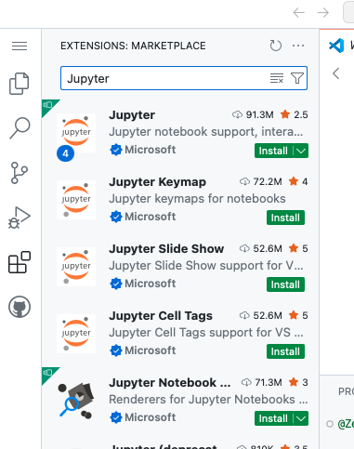

- Press Ctrl + Shift + P (Windows) or Command + Shift + P (Mac) to select a command palette again, then type “create” to bring up Create New Jupyter Notebook and select it from the dropdown. You will see a screen like the image below.

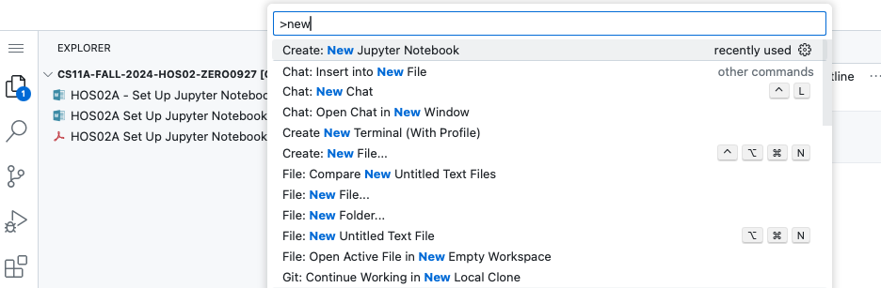

Section 2: Run a simple program in Jupyter Notebook

- Type print(“hello”) into the notebook like the following, click the triangle to run it.

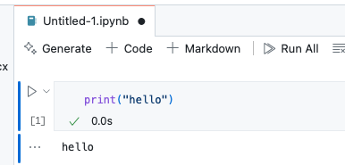

- Create a new file named “HOS02.ipynb”. The .ipynb stands for interactive Python Notebook. This is a JSON-formatted file that contains the code cells, text cells, output results, and metadata.

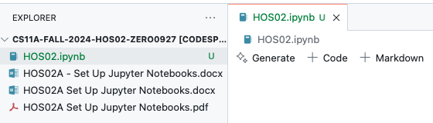

- Click ‘+ Code’ to type the following source code and run it by clicking the triangle button.

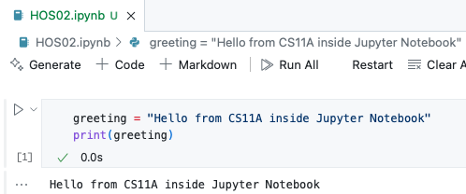

- Let's explore the GitHub Codespaces environment a little more. GitHub Codespaces has built-in AI tools that we can use to better understand our code and environment. We can use Copilot in our codespace. Let's look at the chat window. If the chat window is closed, click on the chat icon shown below.

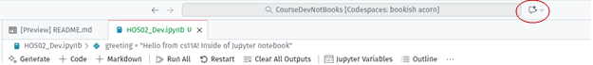

Here we can ask several questions. Since we are inside GitHub Codespaces, the LLM (Large Language Model) is powering the chatbot. This allows us to ask questions about the page that we are working on and get better answers.

- Use the following prompt. In a new code cell, press Ctrl + i, and this will generate the prompt window. Enter this prompt. "What is Copilot and how does it work? Create markdown text with your answer”. Markdown is a convenient way to display text messages in Jupyter Notebook.

- Next, in the Copilot chat, in your own words, ask GitHub Copilot for some best practices in using AI assistants. How can they be used without the agent doing all the work?

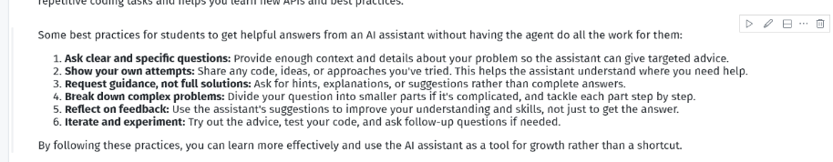

- Push the work to the GitHub repository following the same procedure from HOS01A. To start, select the Source Control icon for the far-left gutter . Click you will see a number in a blue bubble. Click on the plus to stage all changes. Add a brief message and click on commit. Then click sync changes to add submit your changes. Double-check your repository to see that your changes are there and are not only in your GitHub Codespaces. You can use this link as a reference if you are having issues with pushing your work to GitHub.

